|  |  |
| --- | --- |
|  | **“Historic Newcastle” (2nd announcement)**  **Monday 3rd November 2014 - meet for 11am in Newcastle**  **Please address all queries to John Bibby *jb43@york.ac.uk* or 01904-330334.**  **If you have already booked, please do not re-book: JB will contact you further.** |

**Please join us** on a day-trip to Newcastle (self-travel): snacks, guided walking tour, optional public bus tour, talks and lecture all included.

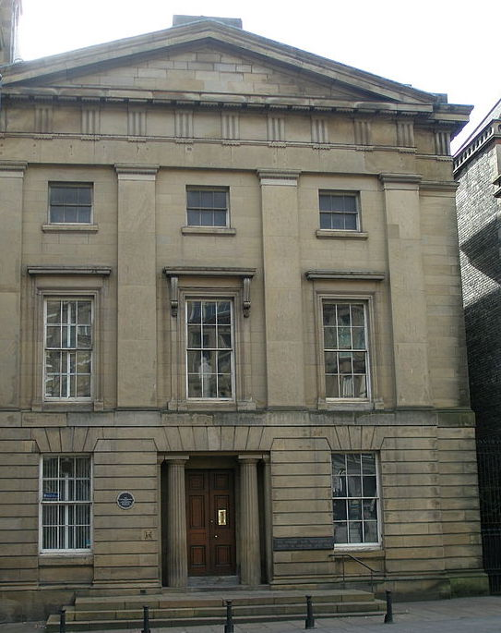

**Summary** (TBC: further details still being developed)

* c. 9.30: leave York by train (own choice, individually or in groups)
* 10.30 for 11am: Meet in Newcastle Lit & Phil (illustrated: 150m E of station):

Presidential Welcome; snacks; introduction to Lit & Phil and Newcastle generally

* 12-5ish:  Walking & bus tours of Newcastle (incl. lunch options)
* 5.30: Social event with Lit & Phil members; snacks
* 6pm: Lit & Phil lecture: *“Emperor of Industry: Lord Armstrong of Cragside”* (Ken Smith)
* 7-8pm: return to York by train. (Some may go for a drink first.)

Our base for the day will be the Newcastle Lit & Phil (*f*.1793), whose extravagant building*, impressive library and excellent coffee will be found some 150m E of Newcastle Central Station, at the top of Westgate Road (postcode NE1 1SE).

Ken Smith, our guest lecturer, is author of *“Emperor of Industry”*, a biography of William Armstrong (1810-1900).

*Your fee includes morning and afternoon snacks, talks & lecture in Newcastle Lit & Phil, walking tour, entries, guides, gratuities, evening lecture, £3 YPS administration fee.*

* The Lit & Phil building has “*a pedimented Greek Revival front of excellent ashlar. Big steps up to the entrance of fluted Doric columns in antis. Imperial stair inside, … Parthenon frieze sculptures … Radical barrister James Losh … galleried library … honeysuckle frieze*” (new Pevsner - highly recommended; available for perusal in YPS Lodge; ISBN 928-0-300-12664-8; a bargain online at a tenner, also available at Newcastle Lit & Phil).

***JB can advise on travel. Train tickets generally available 12 weeks in advance.***

*Trains every 15 mins from 8am to 11am; every 20-30 mins on return after 7pm; journey time c.60mins. (Cost with railcard from c.£11 return.)*

The Yorkshire Philosophical Society accepts no responsibility for any loss or injury suffered while taking part in its activities. There will be approximately 1 mile of walking in total, including some cobbles, steps and slopes. Please dress appropriately and advise us in advance if you may require assistance, which we shall do our best to provide. Participants are advised to consider appropriate insurance cover.

- - - - - - - - - - - - - - - - - - - - - - - - - - - - - - - - - - - - - - - - - - - - - - - - - - - - - - - - - - - - - - - - - - - - - - - - - - - - - - - - - - - -

Please return with your cheque to:  YPS, The Lodge, Museum Gardens, York, YO1 7DR

**“Historic Newcastle” visit – 3 November 2014**

**NB: If you have already booked, please do not re-book: JB will contact you further.**

**I/We would like** to reserve _____ place(s) at £20pp for YPS members; £23 for non-members.

**We will make our own travel arrangements.**  Cheque enclosed, value £ __________ payable to YPS.

**(The former “Option B” (YPS to book rail tickets) is no longer available for new bookings due to the passage of time.)**

**Name(s), address** and special requirements (if any) . . . . . . . . . . . . . . . . . . . . . . . . . . . . . . . . . . . . . . . . . . . . . . . . . . . . . . . . . . . . . . . . . . . . . . . . . . . . . . . . . . . . . . . . . . . . . . . . . . . . . . . . . . . . . . . . . . . . . . . . . . . . . . . . . . . . . . . . . . . . . . . . . . . . . . . . . . . . . . . . . . . . . . . . . . . . . . . . . . . . . . . . . . . . . . . . . . . . . . . . . . . . . . . . . . . . . . . . . . . . . . . . . . . . . . . . . . . . .

Tel.:   . . . . . . . . . . . . . . . . . . Email (caps. please): . . . . . . . . . . . . . . . . . . . . . . . . . . . . . . . . . . . . . . . . . . . . . . . . . . . . . Mobile phone (for contact on the day): . . . . . . . . . . . . . . . . . . . . . . . . . . . . . . . . . . . . . . . . . . . . . . . . . . . . . . . . . . .

***NB: Confirmations will be sent by email.  Please enclose s.a.e. if you prefer to be contacted by post.***

**Please contact JB if you require further advice. If you have already booked, please do not re-book: JB will contact you further.**

The Yorkshire Philosophical Society accepts no responsibility for any loss or injury suffered while taking part in its activities. There will be approximately 1 mile of walking in total, including some cobbles, steps and slopes. Please dress appropriately and advise us in advance if you may require assistance, which we shall do our best to provide. Participants are advised to consider appropriate insurance cover.