**Behind the scenes tour of the**

**Yorkshire Museum Education Department**

3pm Wednesday 28th January 2015

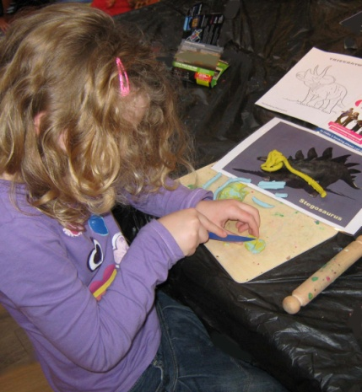Ever wondered what those little troops of children eagerly checking in at the museum are going to spend their day doing? Now is the time to find out.

Over the last three years school workshops at the Yorkshire Museum have increased by nearly 50% and it is becoming a much more popular venue for school visits. Learn about the range of art, history and science workshops and projects currently offered for schools at the Yorkshire Museum, including a look at the objects children can handle. Plus find out about other exciting projects based on the Museum's collections which young people have been involved with.

**Cost: £5.00 per person**

*(this covers administrative costs and a donation to York Museums Trust).*

If you would like to take part, email MLeonardYork@gmail.com

Or return the slip below with your fee and a stamped addressed envelope to:

Margaret Leonard, YPS, The Lodge, Museum Gardens, York, YO1 7DR

*The Yorkshire Philosophical Society accepts no responsibility for any loss or injury suffered while taking part in one of its visits. Participants are recommended to take out appropriate insurance cover*

………………………………………………………………………………………………………………………………………………..

**Visit to the Yorkshire Museum Education Department**

I/We would like …….. place(s) at £5.00 each, and enclose a cheque for £………

(payable to the  Yorkshire Philosophical Society).

Name(s) ………………………………………………………………………………………………………………………………

Address …………………………………………………………………………………………………………………………………

…………………………………………………………………………………………………………………………………………………

email……………………………………………………………  Tel.   ………………………………………