Yorkshire Philosophical Society

Visit to Howsham Mill, North Yorkshire
(A Self-Sufficient Restoration Project)
Wednesday, 15th April 2015, 10.30 – 12.30 approx (?)

Cost: £7.00 per person which includes a donation of £3 to the Mill development fund

Five years ago a YPS group visited the Mill, which was then in the process of rebuilding. This is now complete (see photograph) and on this visit we will see the developments and hear about the plans for its continuing use.

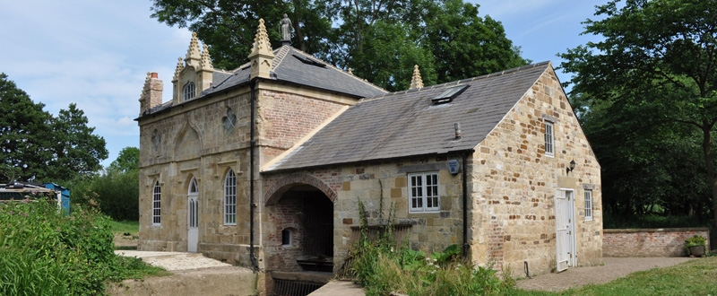

Howsham Mill is a Gothick water mill (attributed to John Carr) which for many years ground the corn grown on the Howsham Hall estate. In 1947 it was closed down and over the years suffered severe decay until it was taken over by a group of enthusiasts. They have re-built the mill house and the granary and converted the water wheel to generate electricity. In addition they are producing electricity by a modern Archimedean screw generator in the adjacent River Derwent. The electricity is fed into the public supply and earns an income to support the development of the mill and its surroundings.

We will be shown round the mill and, over a cup of tea, be able to ask questions and explore the developments for ourselves. The area can be muddy so stout shoes or boots are recommended. We will not be arranging lunch but there are several excellent pubs in the area. I will attempt to prepare a list before the event.

Car parking is limited so car-sharing would be helpful, as would offers of lifts to members without cars. The group will be limited to 30. The journey from York takes about 45 minutes.

The Yorkshire Philosophical Society accepts no responsibility for any loss or injury suffered while taking part in one of its visits. Participants are recommended to take out appropriate insurance cover.

Please return to: Graham Williamson, YPS, The Lodge, Museum Gardens, York, YO1 7DR
together with a stamped addressed envelope and a cheque for £7.00 per person.

Visit to Howsham Mill - Wednesday 15th April 2015

Please reserve ....... places. Enclosed cheque for £........... payable to the Yorkshire Philosophical Society

Name(s) ............................................................................................................................................

Address ............................................................................................................................................

............................................................................................................................................

Telephone ....................................................... Email .......................................................................

I/We would be happy to give a lift to other members Yes ◻ No ◻
I/We would like a lift please Yes ◻ No ◻

The Yorkshire Philosophical Society accepts no responsibility for any loss or injury suffered while taking part in one of its visits. Participants are recommended to take out appropriate insurance cover.

