**1-Day Lifestyle Tour of North Lincolnshire. Wed 1 July 2015. Basic cost £40 per person.**

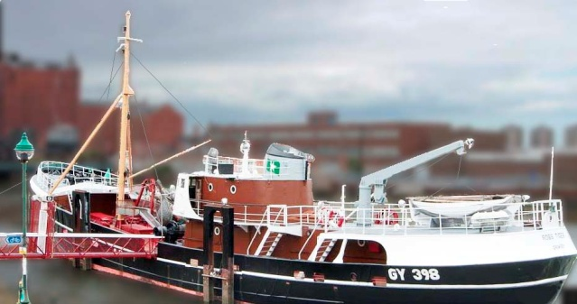 **Summary**

This rather eclectic coach tour contrasts three very different lifestyles- those of the founders of Methodism, of the landed gentry, and of Grimsby fishermen. The cost includes travel by coach, £3 YPS administration costs, all entry fees, two tea/coffee/cakes but **not** **lunch**. Any unspent contingency will be donated to the YPS.

**Tentative Programme**

**0800 depart from Memorial Gardens,** **York**

Brief stop at **Wesley Memorial Methodist Church, Epworth**. This impressive memorial to John and Charles Wesley was built in 1889, and is set in formal gardens.

0930 Visit **Epworth Old Rectory** before they officially open, for tea/coffee/cake and to explore the Physic Garden built in the spirit of John Wesley’s “Primitive Physic”. We then have a guided tour of the rectory- the home of the Wesley family (Samuel, Susannah, John and Charles).

1145 arr **Normanby Hall Country Park**. Explore the walled garden, woodland, and 300 acre park- and grab a quick lunch (not included in tour cost) in the small cafe. When they open at 1300 there is just time for a rapid tour of either the Hall or the Farming Museum, before we leave promptly at 1330. The Hall is a fine Regency mansion built in 1825/30 for the Sheffield family, and later modified in 1906/8 to the designs of York’s Walter Brierley. An earlier member of the Sheffield family became the [Duke of Buckingham and Normanby](http://en.wikipedia.org/wiki/Dukes_of_Buckingham_and_Normanby) in 1703, and built what is now known as Buckingham Palace.

1425 arr **Grimsby Fishing Heritage Centre**, where we will split into two groups. Group 1 will have a 1 hour guided tour of the Ross Tiger trawler, while Group 2 has tea/coffee/cake and explores the Museum. The groups then swap over before we leave just before 1700. You will have the opportunity to experience a moving deck and get an insight into one of the toughest jobs in the world.

**1900 arrive in York**

If you would like to join this tour, please complete the booking form and return it with your cheque (for £40 per person, made out to “YPS”) to the YPS Lodge as soon as you can, and anyway by Friday 24 April 2015. I will then advise everyone if the tour is viable. Please enclose a SAE or email address. Please also note the YPS Booking Terms and Conditions, (on web booking form http://www.ypsyork.org/events/1-day-lifestyle-tour-of-north-lincolnshire/), which also define a strict cancellation policy and emphasise the need for personal travel insurance which should include cancellation cover.

Rod Leonard, Tour Organiser, mobile 079 868 868 14, email RLeonardYork@gmail com

--------------------------------------------------------------------------------------------------------------------------------------------------

**BOOKING FORM for LIFESTYLE TOUR of NORTH LINCOLNSHIRE**

**Name 1 Name 2**

**Address**

**Email Home phone Mobile**

I have read and understood the YPS Booking Terms and Conditions, (on web link) that also define the cancellation policy and emphasise the need for personal travel insurance which should include cancellation cover. I enclose a cheque for £40 per person, made out the “YPS”.

**Signed Date**

**Please return signed form, the cheque, and SAE/email to the YPS Lodge, Museum Gardens, York, YO1 7DR**