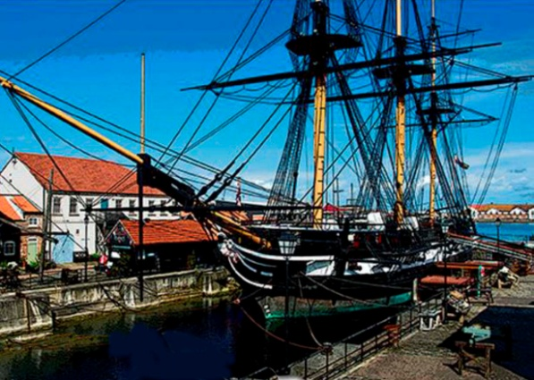**Wood and Iron - Past Lives on the the North East Coast.**

**Thursday 3 September 2015. Basic Cost £40 pp**

**Summary**

Learn about the working conditions of those who sailed on wooden sailing ships, manned gun batteries defending the coast, or toiled underground in ironstone mines. The cost includes travel by coach, £3 YPS administration costs, all entry fees, morning tea or coffee, but not meals. Any unspent contingency will be donated to the YPS.

**Tentative Programme**

**08.00 dep. Memorial Gardens, York**

**10.00 arr. Heugh Battery**

This is a gun battery that defended the port of Hartlepool in WW1 and WW2. The group will split into two. One group will have tea/coffee/ scone, while the other has a guided tour of the 1860 Magazine, the Command post, a WW1 gun emplacement, the underground magazine, and a WW2 gun emplacement.

**11.45 arr. Hartlepool’s Maritime Experience**

Includes HMS Trincomalee, built in India in 1817, and the oldest British warship still afloat - one of the most important historic ships in the world today. Explore the harsh reality of Nelson’s Navy, the historic quayside, various audio visual displays, the Museum of Hartlepool, and a retired paddle steamer, once the Humber Ferry. Lunch at own cost.

**16.00 arr. Cleveland Ironstone Mining Museum**

Explore part of the Loftus Mine, which was worked between 1865 and 1958, and helped sustain the earlier economic power of Middlesbrough and the Tees estuary. The Museum is being very helpful to our Geological Map Project, and has offered to provide a boulder sized sample of ironstone to be displayed next to the map. This is a good opportunity to build links between the Museum and the YPS.

**17.30 dep. Cleveland Ironstone Mining Museum**

Stop for light evening meal. Not included in tour cost, but with a budget of less than £10. Details will be circulated later.

**20.00 arr. Memorial Gardens**

*To join this tour, complete the form and return it to the Lodge with your cheque for £40 per person, made out to the YPS. To help the organiser, please return the form as soon as possible, by Friday 17thJuly at the latest.*

***Note that the YPS terms and conditions (see web link) apply to this booking.***

*Rod Leonard, Tour Organiser, mobile 079 868 868 14, email RLeonardYork@gmail com*

--------------------------------------------------------------------------------------------------------------------------------------------------

**BOOKING FORM FOR WOOD AND IRON - PAST LIVES ON THE THE NORTH EAST COAST**

**Name 1 Name 2**

**Address**

**Email Home phone Mobile**

I accept the YPS Booking Terms and Conditions, (on website). I enclose a cheque for £40 per person, made out to the YPS.

**Signed Date**

***Please return signed form, the cheque, and SAE/email to the YPS Lodge, Museum Gardens, York, YO1 7DR – by Friday 17th July.***