**Celebration of John Phillips FRS, 1800 - 1874**

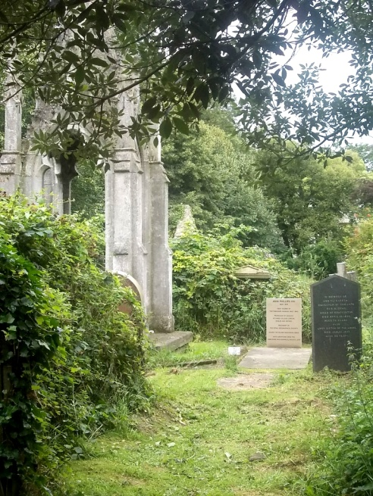**2 pm Sunday 18 October 2015, at York Cemetery**

**No charge, but please book**

**Summary**

As well as being the bicentenary of the famous Geological Map, 2015 is also the bicentenary of the start of John Phillips’ geological career, when he became apprentice to his uncle, William Smith. John Phillips was the first Keeper of the Yorkshire Museum and served the YPS in many capacities over many years. This launched him on a remarkable career, ending up as Professor of Geology at Oxford University. John is buried in York cemetery with his sister Anne, and their gravestone is becoming hard to read. The YPS has therefore commissioned a recognition stone, which has been installed at the head of the grave. We would like to invite you to the unveiling ceremony.

**Programme**

2.00 pm. Meet just inside the gate of York Cemetery, Cemetery Road, York, YO10 5AJ

2.05 pm Brief tour of graves of other YPS past members.

2.30 pm Unveiling ceremony at John Phillips grave.

2.40 pm Short talk in the Chapel on John Phillips, by Dr Liam Herringshaw.

2.55 pm Wine reception in the Chapel

3.30pm Close

**Added bonus.** The blackberries in the cemetery are reputed to be fine and plentiful. Bring a container, and you can pick some to take home

-----------------------------------------------------------------------------------------------------------------------------**Booking Form for Celebration of John Phillips**

**Name 1 Name 2**

**Address**

**Email Home phone Mobile**

**Signed Date**

**Please return the signed form to the YPS Lodge, Museum Gardens, York, YO1 7DR, or email**

**Rod Leonard at** [**RLeonardYork@gmail.com**](mailto:RLeonardYork@gmail.com)**, by Wednesday 7 October**