**Study Tour of Northumbria, 4-8 September 2016- Booking Form**

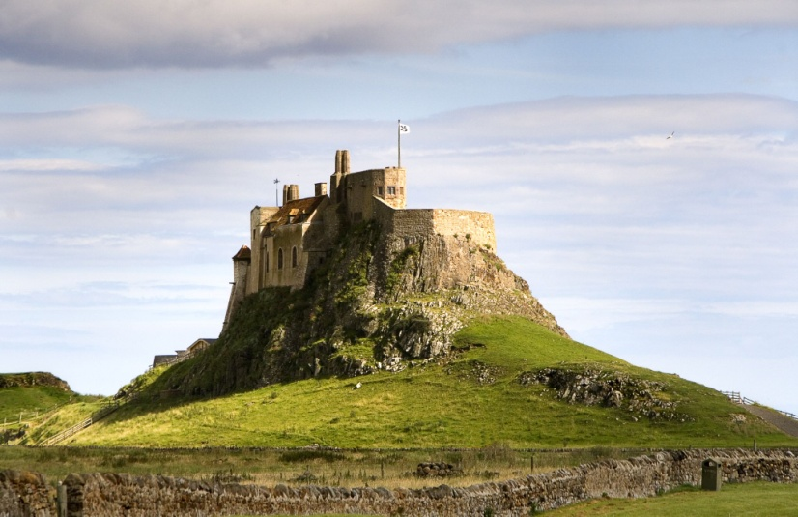**Base Cost £366 pp sharing**   **Singles supplement £80**

Explore the 7thC kingdom of Northumbria, ancient and modern. Subject to weather, the draft itinerary includes National Trust’s famous Cragside; Seahouses; a boat trip to the Farne Islands; Bamburgh Castle; Grace Darling Museum; a whole day to explore the many attractions in Gateshead and Newcastle (including a boat trip down the Tyne to the sea); option tour of Victoria Tunnel; Holy Island; Lindisfarne Castle and Priory; Alnwick; a barbeque; the Angel of the North; and Beamish Museum. See details in “Further Information”.

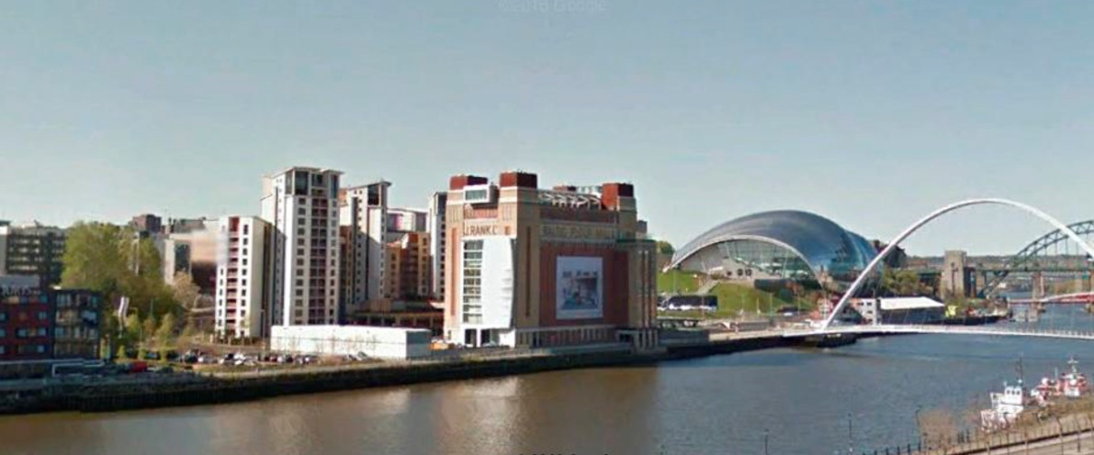We will stay in the 3* Jurys Inn on the Gateshead Quays, with great views of the Newcastle Quayside. The iconic Millennium footbridge over the Tyne, the Baltic Centre for Contemporary Art, and The Sage Music Centre are all a few minutes’ walk away.

This trip makes extensive use of National Trust and English Heritage attractions (free to many YPS members), and these are therefore not included in the base cost. **Non NT/EH members should allow up to about £40 pp for these attractions**, some optional, though it may be possible to enter free as guests of fellow tour participants with higher grade memberships. The base cost includes the coach, DBB, most attractions, some teas/coffees, YPS administration charges, and tips. Any unspent contingency will be donated to the YPS. Costs of some self-directed periods are not included.

If you would like to come on this trip, please detach and return the following booking form asap (deadline Friday 15 July) to Frances Chambers at the YPS Lodge, Museum Gardens, YO1 7DR and enclose a cheque for £50 pp deposit made out to the YPS. Please include a SAE if you are not on email. **PTO for further info**

Further details from Rod Leonard [RLeonardYork@gmail.com](mailto:RLeonardYork@gmail.com) Mobile 079 868 868 14

**Study Tour of Northumbria- 4-8 September 2016- BOOKING FORM**

**Name 1** email Phone/mobile

Address

NT/EH member? Adult/senior?

Dietary or other constraints?

**Name 2** email Phone/mobile

Address

NT/EH member? Adult/senior?

Dietary or other constraints?

**Room Preference** Double Twin Single Easier access

Person 1 Person 2 **Total amount**

Base cost £366

Singles Supplement £80

Optional tour of Victoria Tunnel £6

I/we recognise that this trip involves a range of physical activities and is at own risk. I/we have read and understood the YPS Booking Terms and Conditions and General Assessment of Probable Risks (see overleaf). I enclose a cheque for £50 pp deposit made out to the “YPS”, and will pay the balance before Friday 29 July 2016 assuming the tour is judged viable in mid July.

**Signed Date**

**Please detach & return signed form, with £50 deposit pp, to YPS Lodge, Museum Gardens, YO1 7DR**

**General Assessment of Probable Risks**

It is the responsibility of each participant to assess each attraction/activity in the light of their own fitness, the weather, and other factors. Please consult the websites for individual attractions/activities. As a rough guide and in summary only, consider in particular-

**Cragside** gardens have some rough and steep terrain. The House should be more benign.

**Boat trip to Farne Islands** may be a bit rough. Sea sickness. Steps to climb on and off boat. Rough paths, possibly slippery particularly as tide will be low. Would be cancelled if weather too severe.

**Bamburgh Castle** has steep stairs.

**Boat trip on River Tyne**. Relatively sheltered. Possible steps and gangways.

**Victoria Tunnel (optional)**. 15 minutes walk from Millennium Bridge, then 2 hour tour. Dark, possibly slippery. A few steps. Emergency exit via a vertical ladder. Helmet and torch provided.

**Lindisfarne Castle**. Steep slopes and spiral staircases.

**Beamish Museum**. Quite a bit of walking at own pace, but a circular transport system is provided between attractions.

If you have any concerns or need further advice, please let me know. It may be possible to find a compromise solution.

**YPS Booking Terms & Conditions**

**Booking** To book an event, complete and return a booking form together with the full sum due (for short visits), or the stipulated deposit (for tours), as appropriate. A receipt will be issued. This is not a guarantee that the tour is viable and will run.

When the number of people booking reaches the point at which the tour / visit becomes viable (viability point) you will be sent a confirmation of your booking and that the event will run, subject to booking numbers remaining above the viability point. This will confirm the date by which any balance payment must be made. Balance payments should reach the Lodge at or before the stated due date.

In the case of day or part-day visits, no refunds will be made in the event of cancellation after a visit has been declared viable.

**Cancellations**

By YPSYPS will endeavour to offer an alternative event of equal or greater value than the one cancelled. Where that is not possible all moneys paid against the cancelled event by the member booking will be repaid in full.

By the person booking Cancellation charges will be made as follows –

* All cancellations will incur an administration charge of £3/person/day of event or tour. Liability for this charge will occur from the date of booking. No administration charges will be made in the case of an event failing to attract the numbers of people needed to become viable, and all moneys sent with a booking form will be returned in full.
* A cancellation made after the notified viability date will lead to the loss of deposit.
* A cancellation after the date set for balance payments, or any set refund cut-off date, as appropriate, will lead to the loss of all moneys paid out by the person booking.

**Insurance**

The YPS accepts no responsibility for any loss or injury suffered while taking part in one of its visits. Participants are advised to consider taking out appropriate travel insurance, which should include cancellation cover.

**Study Tour of Northumbria – Further Information**

**Draft Itinerary**

**Sunday 4 September**

0800 dep Memorial Gardens, York (Stephensons Coach)

1115 arr Cragside, coffee stop on way

1445 dep Cragside (cost £13.50 House and Gardens for non-NT members)

1545 arr Jurys Inn, Gateshead Quays.

Check In. See Sage, Baltic Centre, Millennium Bridge (all free))

1930 Dinner

**Monday 5 September**

0845 dep Hotel.

1015 arr Seahouses. Time for quick coffee + purchase of optional picnic lunch for Inner Farne

1100 boat trip to Farne Islands (many seals + a few birds) (subject to weather)

Optional 1 hr landing at Inner Farne (see St Cuthberts Chapel etc) Cost £6 for non-NT members.

1230/1330 return from boat trip. Earlier return allows lunch on shore

1340 dep Seahouses

Grace Darling Museum/ St Aidan’s Church

1500 arr Bamburgh Castle

1700 Tea & biscuits

1850 arr Jurys Inn

1930 Dinner

**Tuesday 6 September**

0845 Morning at leisure to explore Gatehead/Newcastle

1200 Boat trip down the River Tyne of the sea. (subject to weather)

1500 Return

1530 Optional 2 hour tour of Victoria Tunnel (cost £6). Victorian wagon way for transporting coal, then a WWII air raid shelter. Helmet and torch provided.

1930 Dinner

**Wednesday 7 September**

0845 dep Hotel

1030 arr Holy Island. Morning is self directed at own cost. Possibilities include Lindisfarne Priory, Lindisfarne Centre, and walks. A shuttle bus runs every 20 minutes.

1300 Lindisfarne Castle (cost £6.20 for non-NT members, plus £2 shuttle bus), Gertrude Jekyll garden etc.

1500 dep Holy Island

1545 arr Alnwick. Self directed at own cost.

1725 dep Alnwick

1930 Dinner

**Thursday 8 September**

Check out and load bags into coach

0845 dep Hotel

Angel of the North

1000 arr Beamish Museum. Self directed. Covers a wide area with circular transport system.

1500 dep Beamish

1700 arr York