**Tea at the Lodge – 'Second Sitting'**

**Wednesday 23rd March at 3pm**

*(This event is intended to welcome new members. More established members should not feel left out, as later in the year we hope to run a similar, but more detailed event for them. Details will follow in the next newsletter.)***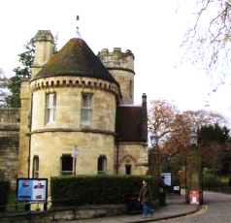**

We would like to welcome to this event those who have joined the YPS in the last year or two and would like to know a bit more about the Society. It will provide a brief introduction to our history and current activities.

Participants will be invited to meet a number of people who make things happen, including our chairman, Catherine Brophy, and our ever-helpful clerk, Frances Chambers.

The main part of the event will take place taking in the first-floor reading room, over an informal afternoon tea, but there will also be an opportunity to peer into the nooks and crannies of the strange little building that is now the hub of our organisation, but was once the home of the resourceful Fanny Baines, whose family served the Society in many different ways.

*There is a rather tricky spiral staircase, so this might not be suitable for those with mobility problems. Please let us know if this is the case, and we will try to arrange a different visit tailored to your needs.*

*This is a repeat of the event on March 16th, which is now fully booked.*

*If you would like to take part, please complete the booking form and return it with the fee of £5 to the YPS Lodge as soon as you can. Please also note the YPS Booking Terms and Conditions listed on the website at http://www.ypsyork.org/events/tea-at-the-lodge/*

*For further information, email MLeonardYork@gmail com*

--------------------------------------------------------------------------------------------------------------------------

**Booking form for 'Tea at the Lodge', 23rd. March at 3pm.**

**Name Date of joining YPS**

**Address**

**Email Home phone Mobile**

I enclose a cheque for £5 per person, made out the “YPS”.

I accept the YPS Booking Terms and Conditions given on the websiteat http://www.ypsyork.org/events/tea-at-the-lodge/.

**Signed Date**