Geology in the Gardens
This guide aims to encourage the inner ‘field geologist’ of the user, by examining examples of rocks found throughout Museum Gardens. These gardens were laid out in a Gardenesque Style after the construction of the Yorkshire Museum in 1830. The Garden Manager is responsible of keeping of the Gardens to an exceptional standard; and they have won numerous awards.
Over the years, a number of interesting rocks were brought into the gardens, either as building stones, or to interest the visitors.
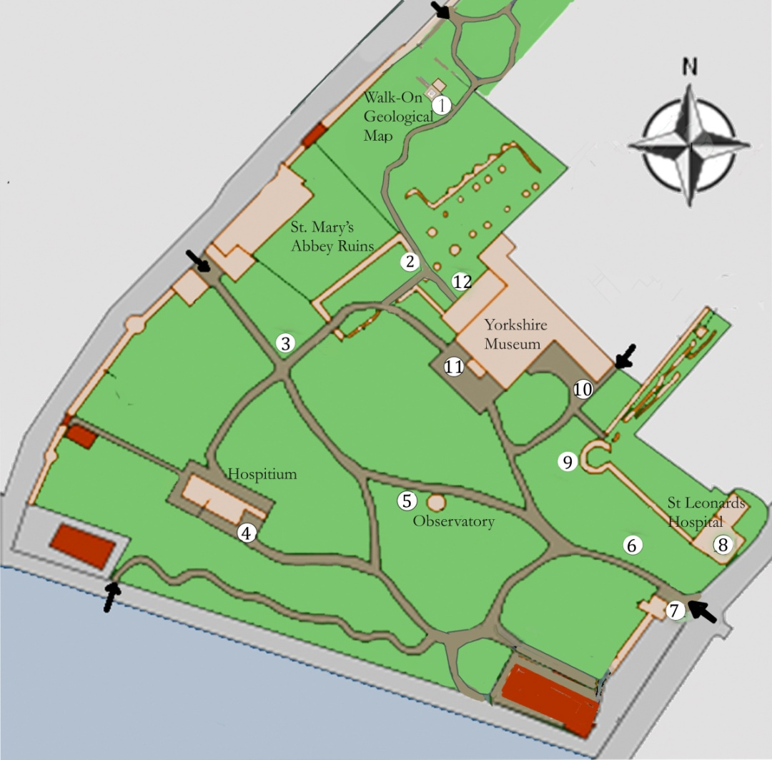
Follow the trail:-
1). Walk-on Geological Map
The walk-on pebble mosaic was created by artist; Janette Ireland. It depicts the Yorkshire section of William Smith’s famous 1815 geological map. It was commissioned by the Yorkshire Philosophical Society in 2015 to celebrate the 200th anniversary of the map. Twelve samples of the rocks represented in the pebble mosaic are displayed around the Mosaic. More information can be found in leaflets available on the YPS website.
2). St Mary’s Abbey Ruins
The Abbey and the surrounding walls were built from Magnesian Limestone. It is a beautiful honey colour, but wind and rain are taking their toll. Can you identify signs of weathering on the ruins? Look for carvings and crumbling areas.
3) Limestone Rockery
The rocks here were brought from West Yorkshire, to demonstrate the formation known as limestone pavement. This formation is now protected, and today it would be illegal to move rocks from where they belong. The plants which grow here are specially adapted to the limestone.
4). The Hospitium
This building was part of the original medieval abbey. On the south-east side, courses of thin red brick in the ruined and arched wall can be observed. Underneath the arches there are two samples of Millstone Grit, try and work out why they are named so.
The name is given because of the value of this stone for millstone production in the past.
Look at the stone coffins seen on the adjacent patch of grass. The large ones are Roman sarcophagi, carved from Millstone Grit. They were found in 1874 when the Station Hotel was being built across the river. According to P.C Buckland, the sarcophagi would have stood alongside the Roman Road. The smaller coffins were used by the monks from the Abbey.
5). Observatory
The Observatory located in the centre of the Gardens was built between 1832-3, of Hackness Stone, from a quarry near Scarborough. Inside the Observatory, the telescope is situated on the upper floor of the building. It rests on a vast slab of Elland Flag Sandstone, to keep it steady.
6).Glacial Erratics
A number of rocks collected in Yorkshire by early YPS members have been placed in the flower bed. They were moved from their original home by glaciers. Most are Shap Granite from the Lake District, but one is limestorne from Filey, and shows the scratches made as it scraped across the ground.
7). Museum Gardens Gates
The gates of the Gardens are hung on piers of sandstone. Can you see any unusual features in this rock?
Ochre Balls.These are localised deposits of a natural pigment.
The Lodge next to the gates is constructed from Magnesian Limestone - where else was this seen? It is now the headquarters for the YPS which led to the formation & growth of the Museum & Gardens.
8). St Leonard’s Hospital Ruins
The ruins only hint at the significance of the Hospital in medieval York. It was founded soon after the Norman Conquest. It is believed to be the largest medieval hospital in northern England
To the entrance of the ruins, directly opposite the Lodge, the footings of the wall to the left are made up of Magnesian Limestone, brick, and Oolitic Limestone, which contains little balls, like ‘fish roe’.
While you are here, note the Victorian drinking fountain in the railings. It has a number of different rocks, including granite, brought from Scotland.
9). Multangular Tower
As we head back towards the museum, note the different layers in this tower, originally built by the Romans. They used small blocks of stone, and a few courses of red brick. The larger stones on top were added in mediaeval times.
10). Manor Cottage
To the left of the path approaching Manor Cottage, in the fern garden are two very different, but interesting, rock samples. See if you can find them. The first, quite close to the path, has a strange pattern of holes, which is the imprint of a tree fossil. The second is further back, and is a column with a hexagonal cross-section. This is Basalt, which forms in volcanoes.
Manor Cottage itself is mainly built from Magnesian Limestone, taken from the abbey. If you look closely underneath the old doorbell, you can notice a little hole containing crystals, which formed at the bottom of the hole. This is a geopetal - also known as a ‘way-up indicator’ which can tell us if the rock is the right way up, or if it has been used upside down.
11). Yorkshire Museum
Like the Observatory, the Museum is built from Hackness sandstone. It has had animals burrowing through it as it was settling. This is known as ‘bioturbation’. Can you see any sign of these animals, or the tracks they made? Do you think it was a good material to build from? Have any repairs been needed?
12). Tempest Anderson Hall
The extension to the east of the Museum was paid for by a famous York Volcanologist; Tempest Anderson (1846-1913). Is it built from the same rock as the Yorkshire Museum? No, it is actually a very early example of reinforced cast concrete.
We suggest you now go in to the Museum, where you can find lots of interesting exhibits and information about geology

