Members of the Yorkshire Philosophical Society are invited to a private viewing and reception

The Streets of York: Four Centuries of Change

**Monday 12 November** 2018, from 12.30pm to 2pm

at **the McClaggan Hall, St. William’s College**, College Street, York

**cost £13 per person** (including a glass of wine and YPS admin. fee)

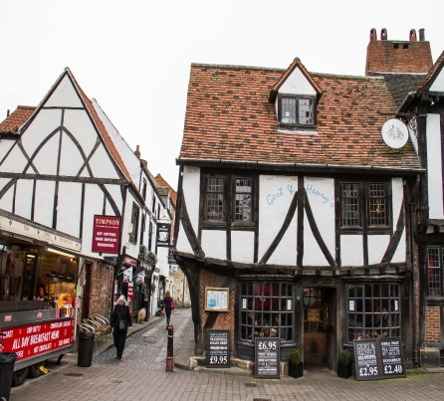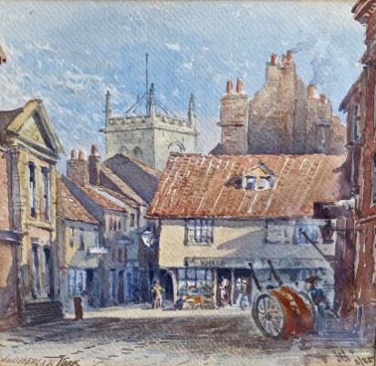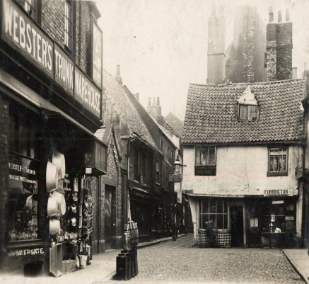

An exciting exhibition of artwork and photographic images, capturing the changing streetscapes of our historic city through the last four centuries.

*In aid of YORK AGAINST CANCER, YORK MINSTER*

*and YORK CIVIC TRUST CIVIC ENHANCEMENT FUND*

*We understand that a book, which will also serve as a catalogue for the exhibition, containing most of the images on view will be on sale at the reception. The monies raised by the exhibition and book sales are being donated to the above charities.*

*If you would like any further information about the exhibition or book, please contact Mark Davies, on behalf of the exhibition organisers’ committee (Ron Cooke, Darrell Buttery, Chris Shepherd, Steve Lewis, Duncan Beale and Mark Davies). Email:* [***mrdclifton@gmail.com***](mailto:mrdclifton@gmail.com)

***If you would like to attend this event, please return the booking form below to the Lodge***

***by 1st October with your cheque.***

***YPS terms and conditions apply. See the website*** <https://tinyurl.com/yps-act-t-c>

***or ask at the Lodge.***

**✂...................................................................................................................................................**

The Streets of York: Four Centuries of Change

To: Margaret Leonard, c/o YPS, The Lodge, Museum Gardens, York, YO1 7DR

Please reserve …….. place(s) for me/us. A cheque for £ ……...… made out to Yorkshire Philosophical Society is enclosed

Name(s) ………………………………………………………………………………………………………………………………………………………

Address ………………………………………………………………………………………………………………………………………………………

Tel. No. …………………………………..…………………………………Mobile…………………………………..…………………………………

(A mobile number is very useful if we need to contact you on the day)

Email*…………………………………………………………………………..…………………

*Acknowledgement will be by email. Please enclose SAE if postal acknowledgement required instead.