
Yorkshire Philosophical Society

Leeds Library and Thackray Medical Museum
Monday 29th April 10am to 4.30pm
£38 per person includes lunch, entry and tour fees and morning refreshments
The Tour begins at The Leeds Library in the city centre. Founded in 1768 as a proprietary subscription library, it is now one of the oldest surviving examples of this sort of library in the British Isles. We will have a guided tour and tea/coffee and biscuits in two groups. We will then enjoy a two-course lunch at the nearby Victorian “Whitelocks Ale House”. In the afternoon we will visit the Thackray Medical Museum where we travel back in time to Leeds in 1842 where a lecturer will take us through a Victorian Slum Street, (non-seated talk). This is a last chance to see this Museum before it closes for redevelopment.
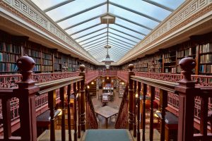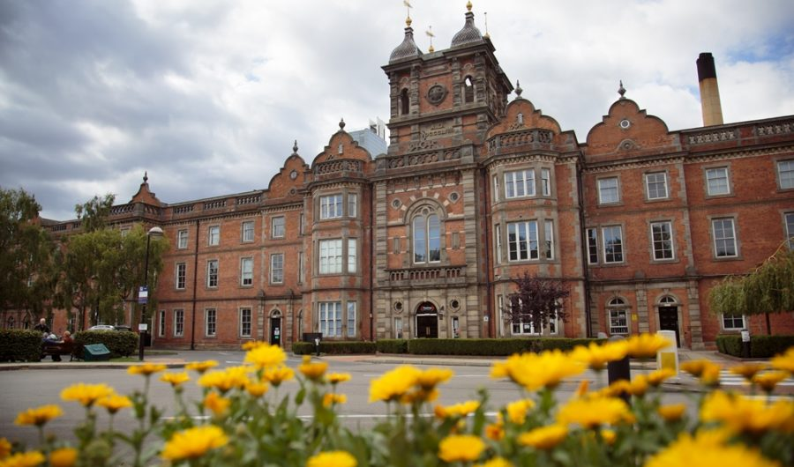
Further details will be sent and all costs are included except for shared taxis after lunch to reach the Thackray Museum, and the journey to and from home to Leeds.
If you would like to join this tour, please return the booking form below to the Lodge with cheque.
YPS terms and conditions apply. See the website https://www.ypsyork.org/groups/social-group/yps-activities-booking-terms-conditions-2/ or ask at the Lodge.
...................................................................................................................................................................
Leeds Library and Thackray Medical Museum 29th April
To: Catherine Brophy, c/o YPS, The Lodge, Museum Gardens, York, YO1 7DR

Please reserve …….. places for me/us. A cheque for £ …..… made out to YPS is enclosed

Name(s) ………………………………………………………………………………………………………………………………………………………
Address ………………………………………………………………………………………………………………………………………………………
Tel. No. …………………………………..…………………………………Mobile…………………………………..…………………………………
(A mobile number is very useful if we need to contact you on the day)
Email*…………………………………………………………………………..…………………
Please note travel to Leeds is not included but public transport details will be sent o you.

Special Dietary Needs? ……………………………………………………………

*Acknowledgement will be by email. Please enclose SAE if postal acknowledgement required instead.
Your personal details will only be stored and used to administer this event.

