Yorkshire Philosophical Society

Duke’s Wood Oil Museum, Kelham Hall, Near Newark
Friday 5th July 2019 10.30am to 4pm
£20 per person to include morning tea/coffee and lunch, and donation to the Museum

Travel is by private car, about 75 miles from York. There should be opportunities for car sharing.
The visit starts at Kelham Hall at 10.30 am with tea and coffee and an informal tour of some of the main rooms of the Hall.
We then have a talk and tour of the Oil Field Museum inside the Hall with Kevin Topham.
A light lunch will be in the Hall Refectory; sandwiches and cakes.
We will then move on to Duke’s Wood Nature Reserve, for a visit and walk around the Nature Trail (no toilets). There is the option of refreshments (and toilets) at a tea shop nearby before returning to York. (Tea is not included in the costs).
A party size maximum of about 16 people is planned.

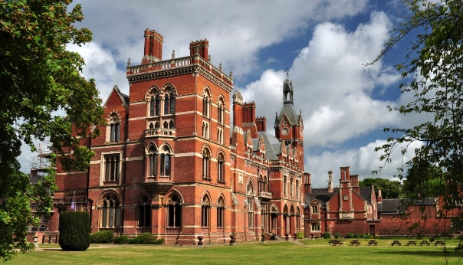
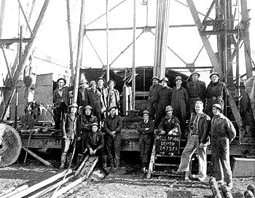
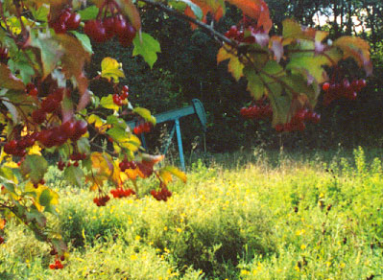

Please detach and complete the form below and return it to the YPS Lodge with a cheque made out to Yorkshire Philosophical Society.
Please include email address (please enclose SAE for further details if no email address available)
Further information is available from Paul Thornley who is organising bookings. ypsgeology@gmail.com

Note that YPS Activities booking terms and conditions will apply and can be seen at the Lodge or online http://www.ypsyork.org/groups/social-group/yps-activities-booking-terms-conditions-2/

BOOKING FORM for Kelham Hall and the Duke’s Wood Museum. Friday 5th July 2019 £20pp
Please return to Paul Thornley at YPS, The Lodge, Museum Gardens, York, YO1 7DR

Please reserve places for this trip. A cheque for £ made out to Yorkshire Philosophical Society is enclosed.

Name 1 __________________________________ Name 2__________________________________________

Address_______________________________________________________________________________________________________________________

Email

Home phone Mobile (for contact on the day)

Any special dietary needs:

Please delete: I/we expect to take our own vehicle. And have spaces for 1/2/3 other passengers.

I/we require a lift from other drivers. Or would consider a lift from other drivers.

