
Yorkshire Philosophical Society
Gainsborough Old Hall, Belton House and Woolsthorpe Manor
Thursday 26th September 8.45am to 7pm
£38 per person includes coach travel, morning refreshments, light lunch, and talk.
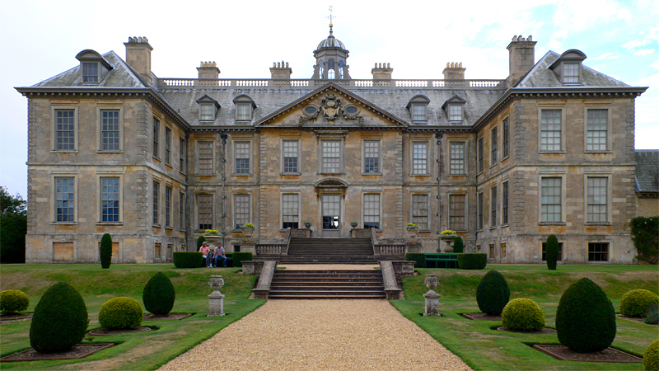
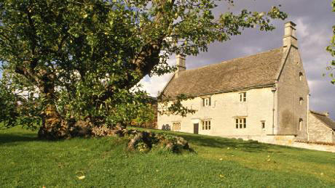
Travelling by coach from York to Gainsborough Old Hall (English Heritage members free) we will have morning refreshments followed by self-guided tour (iGuides are provided). Re-joining the coach for the short journey to Belton House (NT). Here we will have an included light lunch followed by a timed entry tour of the house including the two libraries, which contain many books published before 1800, including the rare Ogilvy book of road maps, the first of its kind in the world. There will also be a short garden guided tour. Later in the afternoon we will conclude our Lincolnshire day with a visit to the nearby Woolsthorpe Manor (NT) where we can pay homage to Isaac Newton’s apple tree. Returning to York in early evening.
Further details will be sent and all costs are included except for entry fees for non-EH/NT members.
If you would like to join this tour, please return the booking form below to the Lodge with cheque.
YPS terms and conditions apply. See the website https://www.ypsyork.org/groups/social-group/yps-activities-booking-terms-conditions-2/ or ask at the Lodge.
...................................................................................................................................................................
Lincolnshire Day on Thursday 26th September 2019
To: Catherine Brophy, c/o YPS, The Lodge, Museum Gardens, York, YO1 7DR

Please reserve …….. places for me/us. A cheque for £ …..… made out to YPS is enclosed

Name(s) ………………………………………………………………………………………………………………………………………………………
Address ………………………………………………………………………………………………………………………………………………………
Tel. No. …………………………………..…………………………………Mobile…………………………………..………………………………… (A mobile number is very useful if we need to contact you on the day)
Email*…………………………………………………………………………..…………………
Special Dietary Needs? ………………………………………………………………………………………………………………………………...
English Heritage member Y/N National Trust member Y/N

*Acknowledgement will be by email. Please enclose SAE if postal acknowledgement required instead.
Your personal details will only be stored and used to administer this event.

