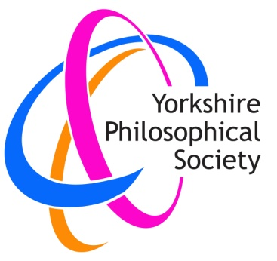
Yorkshire Philosophical Society

Bletchley Park Virtual Tour

20th January 2021 at 2 pm

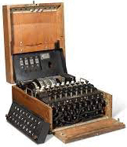
Cost £9.60 per person

You will know the story of the contribution made by the people employed at Bletchley Park in WWII, and the invention of the Enigma machine. Many of you will have visited the facility, and seen the site and machines, but in a large group, the tour can be tiring, and it can be difficult to see and hear the full demonstration. This interactive virtual tour gives a front-row seat in the comfort of your own home.
Bletchley Park runs these virtual activities for groups from primary schools to universities, as well as organisations like the YPS.

What is involved?
Bletchley Park website gives the following description:-
Tour
An immersive 360-degree virtual tour of Bletchley Park’s WW2 history with a learning specialist.
Demonstration
A short virtual demonstration of a WW2 working Enigma Machine from our handling collection.
Workshop Activity. (We chose the following activity)
Interception to Intelligence: Battle of the Atlantic It is 1941 and the Battle of the Atlantic is at its height. Numerous convoys of essential supplies are being sunk by German Wolf packs and Britain is close to surrender. In the role of codebreakers students will intercept, decipher and translate German Naval communications in order to plan a strategy to get the next convoy safely to Liverpool.
During this session students will:
Develop their knowledge and understanding of the role of Bletchley Park in the Battle of the Atlantic.
Briefly describe the process of decryption at Bletchley Park, from when a message is first intercepted until the intelligence is used.
Apply team working, problem solving and strategic thinking skills to obtain and apply scenario based intelligence.

How will this work? - Virtual Learning Video Conferencing

This will be similar to the YPS Zoom lectures and Café Sci presentations, but more interactive, so we will each need to have a webcam and microphone on our device, so we can be seen and heard. Most devices have the necessary bits, but if you are not sure, contact Margaret Leonard via info@ypsyork.org You will see they are also offering a 15-minute ‘dummy run’, which might help us all.

The following information is taken from the Bletchley Park website:-
Team working was essential to making significant breakthroughs at Bletchley Park. During these sessions members will be encouraged to ask questions, solve challenges, work through and engage in a live video conference discussion with our learning specialist.
Pre-downloadable paper learning packs have been designed for each student to support social distancing and individual use requirements. To receive a virtual visit, you will need a computer or mobile device connected to the internet, audio and video enabled device with a web cam. Sessions are accessed via a link provided.
The group will be offered an optional 15-minute pre-session online meeting with a member of the Bletchley Park Learning team, scheduled at a mutually convenient time within the fortnight prior to your learning experience. This is an opportunity to test your software, to ask questions, to enable us to tailor the session to your members and to find out more about how the session will work.
Booking form on next page

If you would like to join this tour, please either return the booking form below to the Lodge with your cheque
or email the form (or the information requested on it) to info@ypsyork.org and make payment either:

- By Paypal - Please go to www.ypsyork.org, click on Payments at top right of Homepage and follow the instructions, stating "Bletchley Park” in the Purpose box. (Paypal account not required.)
- By bank transfer to
Account Name: The Yorkshire Philosophical Society
Account No: 02242648
Bank: Lloyds Bank, 2 Pavement, York, YO1 9LB
Sort Code: 30-99-99
Using your name as a reference

In either case, ‘please don’t forget to email us with the details of your booking and how you have paid.

YPS terms and conditions for single day trips apply, though for this activity we have made no administrative charge. See the website https://www.ypsyork.org/groups/social-group/yps-activities-booking-terms-conditions-2

..............................................................................................................................................................

Bletchley Park Virtual Tour

20th January 2021 at 2 pm

Cost £9.60 per person
(Note this is per person, not per computer, so a couple taking part together will need to book and pay for two places)

To: Margaret Leonard , c/o Yorkshire Philosophical Society, The Lodge, Museum Gardens, York, YO1 7DR

Please reserve ………. place(s) for me/us.

- A cheque for £ ……………. made out to Yorkshire Philosophical Society is enclosed.
- A payment of £ ……………. has been made via Paypal.
- A payment of £ ……………. has been made by bank transfer.
Please tick.

Name(s) ……………………………………………………………………………………………………………………………………………………..
Address ………………………………………………………………………………………………………………………………………………………
……………………………………………………………………………………………………………………………………………………………………
Tel. No. …………………………………………………………………….. Mobile ………………………………………………………………….

Email* ………………………………………………………………………………………………………………….

*Acknowledgement will be by email. Please enclose SAE if postal acknowledgement required instead.

