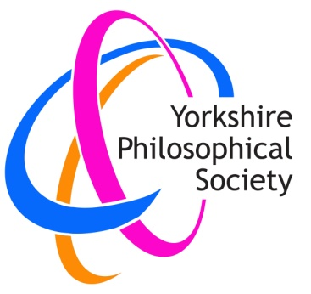
Yorkshire Philosophical Society

Bletchley Park Interactive Virtual Tour

Thursday 27 January 2022 from 2 to 3.30 pm

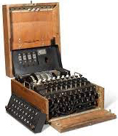
Cost £10.60 per person to include £1 YPS admin charge

You will know the story of the contribution made by the people employed at Bletchley Park in WWII, in breaking the German Enigma code, and decoding their secret messages. Many of you will have visited the facility, and seen the site and the machines they used, but in a large group the tour can be tiring, and it can be difficult to see and hear the full demonstration. This interactive virtual activity by Zoom gives a front-row seat in the comfort of your own home.
Bletchley run these interactive virtual activities for groups from primary schools to universities, as well as organisations like the YPS.

What is involved?
It sounds like a busy afternoon! Bletchley give the following information:-
Tour
An immersive 360-degree virtual tour of Bletchley Park’s WW2 history with a learning specialist.
Demonstration
A short virtual demonstration of a WW2 working Enigma Machine from our handling collection.
Workshop Activity
It is 1941 and the Battle of the Atlantic is at its height. Convoys of essential supplies are being sunk by German Wolf packs. Work in teams to decipher German Naval communications so the next convoy can get safely to Liverpool. (Don’t be intimidated – they run this for age 9 up, and I am sure we can all support each other!)

Please note that in order to run this activity, we need 30 bookings by 17th December.
If you would like to take part, please book as soon as possible either by email (payment via Paypal) or returning the form below to the Lodge with your cheque.
YPS terms and conditions apply. See the website https://www.ypsyork.org/groups/social-group/yps-activities-booking-terms-conditions-2/
...................................................................................................................................................................

Bletchley Park Virtual Tour

Thursday 27 January 2022 from 2 to 3.30 pm

Cost £10.60 per person to include £1 YPS admin charge
(Note this is per person, not per computer, so a couple taking part together will need to book and pay for two places)

To: Margaret Leonard, c/o info@ypsyork.org if you use Paypal, or YPS, The Lodge, Museum Gardens, York, YO1 7DR if you pay by cheque. (Please now write out ‘Yorkshire Philosophical Society’ in full on cheques.)

I/we would like to take part by Zoom in this activity.

Name(s) ……………………………………………………………………………………………………………
Address ……………………………………………………………………………………………………………
Tel. No. ……………………………..…………………………………Mobile…………………………………..

Email*…………………………………………………………………………..…………………

*Replies will be by email, and, of course, we need email to send you the link to join in!

