
Yorkshire Philosophical Society
YPS Garden Party Celebration Event
Thursday 23rd June from 2.30pm to 4.30pm
£18 per person

Members are invited to join us at the York Medical Society Rooms at 2.30pm for a celebration to include a short presentation about the 2022 Bicentenary, followed by time to talk to friends both new and longstanding, over included Afternoon Tea. There will also be a chance to explore the secret garden here, weather permitting, and to look at the Tempest Anderson Exhibition and to take a tour of the building with Dr Neil Moran.

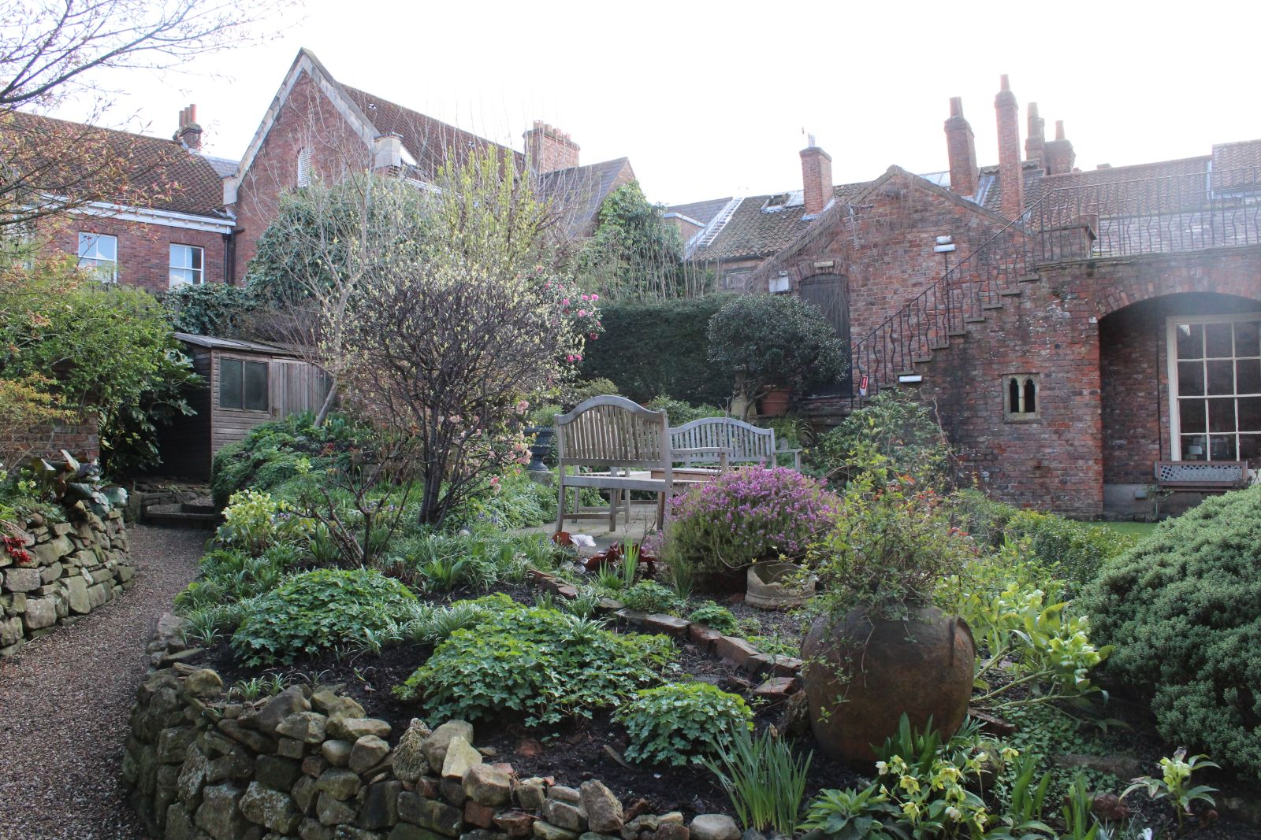
Note that YPS Activities booking terms and conditions will apply and can be seen at the Lodge or online.
http://www.ypsyork.org/groups/social-group/yps-activities-booking-terms-conditions-2/
Please detach and complete the form below and return it to the YPS Lodge with a cheque made out to Yorkshire Philosophical Society. Please enclose SAE if no email address available. Cheques will not be cashed until after the event in case of changes to Covid-19 regulations.
...................................................................................................................................................................YPS Garden Party 23rd June 2022 (Please return this by 9 ^{th} June 2022)

To: Catherine Brophy, c/o YPS, The Lodge, Museum Gardens, York, YO1 7DR

Please reserve …….. Event places for me/us, and ……. House Tour places.

A cheque for £ …..… made out to Yorkshire Philosophical Society is enclosed (£18 per person) N.B. The Society’s full name is needed on cheques now please.
Or pay online by PayPal from the link on our website www.ypsyork.org (no account needed you can use debit/credit cards) and send your details by email: info@ypsyork.org

Name(s) ………………………………………………………………………………………………………………………………………………………
Address ………………………………………………………………………………………………………………………………………………………
Tel. No. …………………………………..…………………………………Mobile…………………………………..…………………………………
(A mobile number is very useful if we need to contact you on the day or in case of changes to Covid-19 rules)
Email*…………………………………………………………………………..…………………
*Acknowledgement will be by email. Please enclose SAE if postal acknowledgement required instead. House Tour places are limited. Your personal details will only be stored and used to administer this event.

