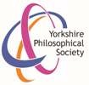
Yorkshire Philosophical Society
Bread and Steel: Visit to South Yorkshire
Thursday 16th June 2022 from 8.30am to 6pm
£30 per person

Our first visit is to Worsborough Mill and Country Park where we will have a talk with Simon, the Miller, and enjoy an included takeaway drink from the Miller’s Café. We continue by coach to Sheffield to the Kelham Island Museum where we will visit the 1916 Sheffield Street, see the Sheffield Simplex car and a demonstration of craft skills, with time to explore other Museum exhibits including the River Don Steam Engine demonstration at 2pm. At 3pm we plan to visit the Glass Museum at the University of Sheffield. The fee includes morning drink, coach travel, driver gratuity, museum donation and £3 YPS admin. Members of York Association of the National Trust (YANT) are most welcome to join us.

The York Pullman coach will leave from Memorial Gardens at 8.30am, leaving Sheffield at 4.15pm for the return journey. Lunch is not included; there is the Island Café and the Millowners Arms, both at Kelham Island, details of lunches can be sent to you or bring your own picnic.

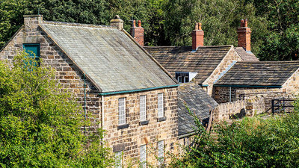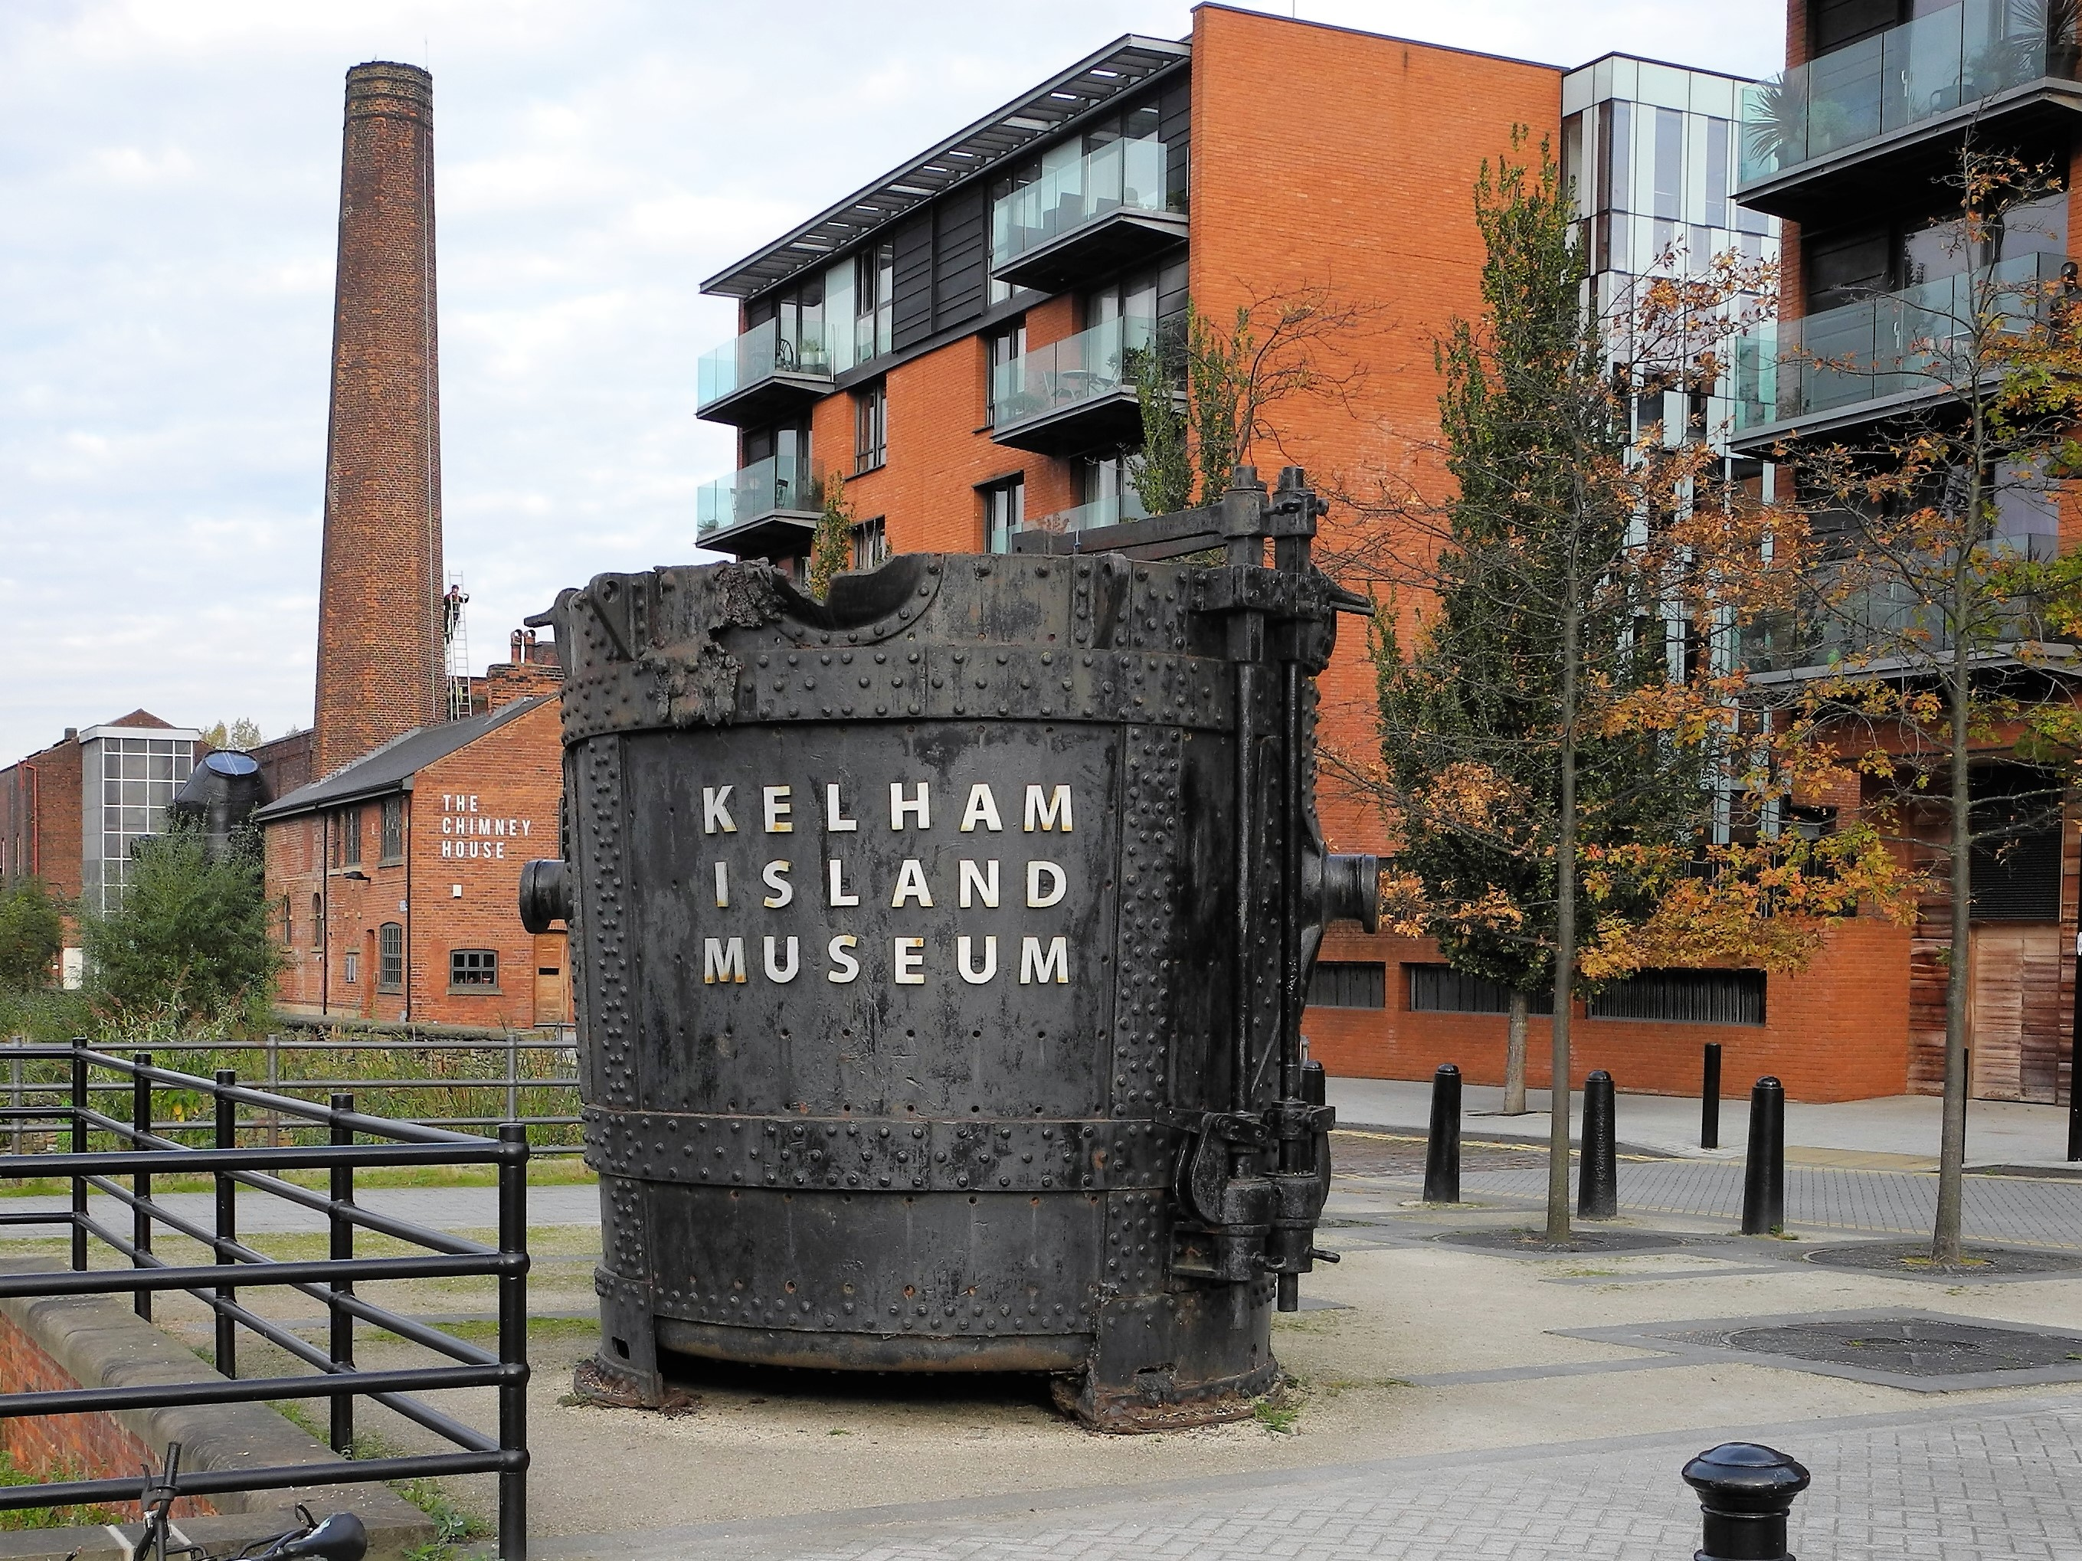

Note that YPS Activities booking terms and conditions will apply and can be seen at the Lodge or online.
http://www.ypsyork.org/groups/social-group/yps-activities-booking-terms-conditions-2/
Please detach and complete the form below and return it to the YPS Lodge with a cheque made out to Yorkshire Philosophical Society. Please enclose SAE if no email address available. Cheques will not be cashed until the event in case of changes due to Covid-19. Your personal details will only be stored and used to administer this event.
................................................................................................................................................................... Visit to South Yorkshire 16th June 2022 (Please return this by 1st June 2022)
To: Catherine Brophy, c/o Yorkshire Philosophical Society, The Lodge, Museum Gardens, York, YO1 7DR
Pay online by PayPal via YPS website, https://www.ypsyork.org/donate-to-yps/ (no account needed; you can use debit/credit card) and email your details to: info@ypsyork.org or send this form with your cheque.
Please reserve …….. places for me/us. A cheque for £ …..… made out to Yorkshire Philosophical Society is enclosed (£30 per person). N.B. The Society’s full name is needed on cheques now please.
Please send Pub lunch details at Kelham Island Museum: Yes /No
Name(s) ………………………………………………………………………………………………………………………………………………………
Address ………………………………………………………………………………………………………………………………………………………
Tel. No. …………………………………..…………………………………Mobile…………………………………..…………………………………
(A mobile number is very useful if we need to contact you on the day or in case of changes to Covid-19 rules)
Email*…………………………………………………………………………..…………………
*Acknowledgement will be by email. Please enclose SAE if postal acknowledgement required instead.

