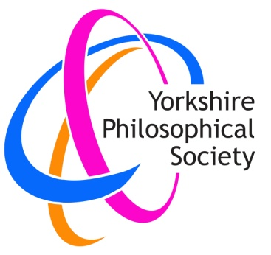
Yorkshire Philosophical Society

Tour of Hemp Farm at Hornington Manor and visit to Bolton Percy
Wednesday 14th June
Cost: £10 per member, £15 non-members.
Travel by car to arrive at Hornington Manor for a prompt start at 10am. Free parking on site.
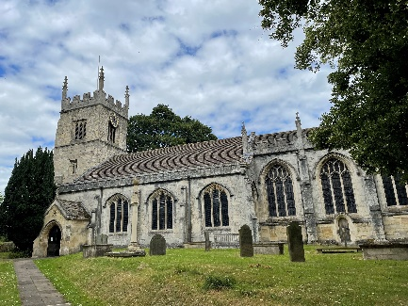
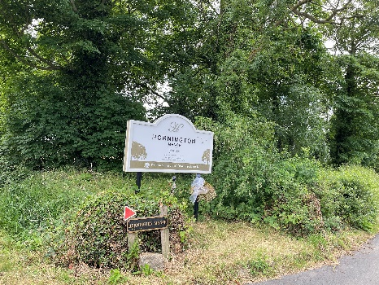
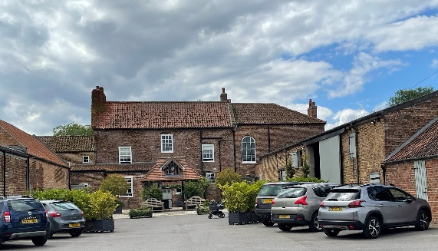

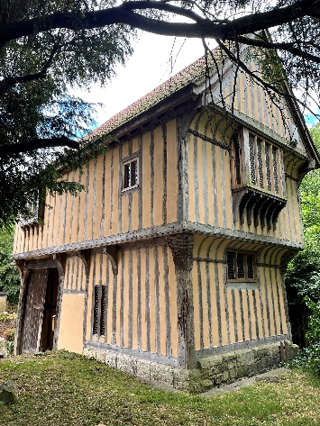
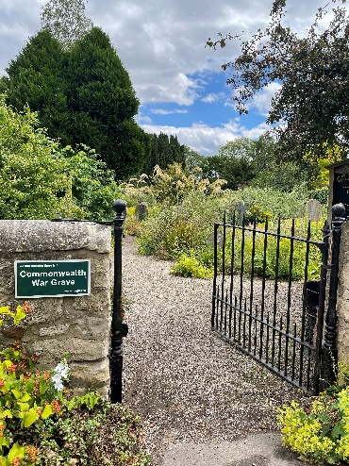
Hemp is a remarkable product with a wide range of useful properties and uses, such as rope making, basket weaving, clothing, mattresses, medicinal uses and recreational drugs! The hemp farm at Hornington Manor produces hemp for luxury bed mattresses for John Lewis among other things. In our tour of the factory by the manager, we learn about the history, growth, properties and uses of hemp, what is produced in the factory and history of the business in Yorkshire and have time for questions.
We then drive to Doylys cafe, just up the road in Bolton Percy, for a light lunch. There is a large designated car park. Doylys cafe offers a good selection of quality, wholesome, simple options including: soup, sandwiches, jacket potatoes, simple dishes, cakes and beverages. You choose and pay for your lunch on the day.

At All Saints Church, Bolton Percy, we explore its history and that of the village and its connection with the Percy family, with a local guide. There are also several interesting historical buildings nearby. We walk to the Cemetery, an international war graves cemetery and a beautifully tended wild garden, before wending our way home around 4pm.

To book, please return the booking form below to the Lodge with your cheque, made out to Yorkshire Philosophical Society (in full) or send the form by email to info@ypsyork.org and pay by Paypal at https://www.ypsyork.org/donate-to-yps/ YPS terms and conditions apply. See the website https://www.ypsyork.org/groups/social-group/yps-activities-booking-terms-conditions-2/ or ask at the Lodge
...................................................................................................................................................................
Visit to hemp farm at Hornington Manor and Bolton Percy
To: Sharon Lusty, c/o YPS, The Lodge, Museum Gardens, York, YO1 7DR
Please reserve …….. place(s). A cheque for £ …..… made out as above is enclosed /Payment has been made by Paypal

Name(s) ………………………………………………………………………………………………………………………………………………………
Address……………………………………………………………………………………………………………………………………………………Mobile…………………………………..……………………………..…Email*………………………………………………………………………
I am interested in *a lift/ *offering a lift ( delete as applicable)
*Acknowledgement will be by email. Please enclose SAE if postal acknowledgement required instead.

