Yorkshire Philosophical Society

Earthleatham – day trip to Kirkleatham
Tuesday February 28th 2023, 10.30am
Cost: £6pp

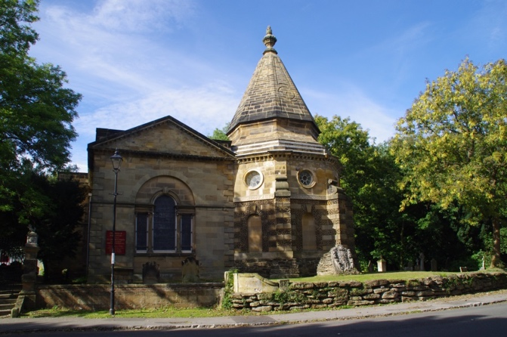
Turner Mausoleum, Kirkleatham (image from Wikimedia Commons)

“Earthleatham” will be a geologically flavoured day-trip to Kirkleatham Museum and village, led by palaeontologist Dr Liam Herringshaw. We will take a walk around the village, which hosts a remarkable number of listed buildings, and hear how geology has played a crucial role in its long and fascinating history. We will also have an opportunity to visit the wonderful Kirkleatham Museum and learn more about the archaeology, local history, and industrial heritage of the area.

Meet - 10.30am at Kirkleatham Museum car park (free parking):
https://redcarcleveland.co.uk/enjoy/find-kirkleatham-museum/

Morning – a 90-minute stroll around Kirkleatham, led by Dr Liam Herringshaw, exploring the 200-million-year history of the village. Highlights include:
  - Sir William Turner’s Almshouses, designed 350 years ago by a pioneering palaeontological architect. https://sirwilliamturner.org.uk/schools/sir-william-turner-s-almshouses,
  - Kirkleatham Walled Garden: https://kirkleathamwalledgarden.co.uk/.
St Cuthbert’s Church & the Turner Mausoleum featuring some remarkable local building stones. https://www.achurchnearyou.com/church/19254/page/15983/view

12.30pm, Lunch – Kirkleatham Museum café: https://www.cafekirkleathammuseum.co.uk/

Afternoon – 2pm: visit Kirkleatham Museum (free entry). A chance to see the new exhibition ‘Megaliths’ https://redcarcleveland.co.uk/enjoy/kirkleatham-museum-exhibitions/
along with permanent displays on ‘Steel Stories’, the pioneering archaeologist Gertrude Bell, and the ‘Saxon Princess’ 7th Century treasures from Loftus.

In the event of very poor morning weather, we can reverse the itinerary, and visit the museum in the morning, and do the walk after lunch.

Parking – Kirkleatham Museum has free all-day parking. In the very unlikely event that all spaces are taken, free parking is also available at Kirkleatham Walled Garden.

To book, please return the booking form below to the Lodge with your cheque, made out to Yorkshire Philosophical Society (in full) or send the form by email to info@ypsyork.org and pay by Paypal at https://www.ypsyork.org/donate-to-yps/
YPS terms and conditions apply. See the website https://www.ypsyork.org/groups/social-group/yps-activities-booking-terms-conditions-2/ or ask at the Lodge

...................................................................................................................................................................

Earthleatham at Kirkleatham Tuesday 28th February 2023
Meet at Kirkleatham Museum 10.30am

To: Paul Thornley, c/o YPS, The Lodge, Museum Gardens, York, YO1 7DR

Please reserve …….. place(s) for me/us at £6 pp.

A cheque for £ …..… made out as above is enclosed /Payment has been made by Paypal

Name(s) ………………………………………………………………………………………………………………………………………………………
Address ………………………………………………………………………………………………………………………………………………………
Tel. No. …………………………………..…………………………………Mobile…………………………………..…………………………………
(A mobile number is very useful if we need to contact you on the day)

Email*…………………………………………………………………………..…………………

*Acknowledgement will be by email. Please enclose SAE if postal acknowledgement required instead.

Please note that this trip begins at Kirkleatham, near Redcar, without arrangements for transport from York.
If you wish to attend, but cannot make arrangements for transport, please state this below and we will see if we can offer advice.

