The Yorkshire Philosophical Society
was formed in 1822, when “natural philosopher” was the term used for a scientist and, although the meaning of the word has changed in modern times, our traditional name has been retained.

From its earliest days the Society’s main interests have been the natural sciences and antiquities, and one of its first achievements was to set up the Yorkshire Museum and its Botanical Gardens to promote the study of these subjects. Although the Museum and Gardens were put into Trusteeship in 1961, the Society maintains a close interest in them. Our office is situated in the former gatekeeper’s lodge at the entrance to the Gardens, many of our lectures are held in the Tempest Anderson Hall, and members receive free admission to the Museum.
Today the YPS is a registered charity. We continue to encourage interest in science and archaeology through our annual series of public lectures. This runs from September to June, covering a wide variety of topics from the fields of science, archaeology, history and social sciences, and includes occasional lectures aimed specifically at a family audience, while our regular Café Scientifique sessions give researchers the opportunity to present their work in an informal setting.
The Society is an ally of the British Science Association.

Founded
1822

Membership
YPS welcomes everyone to share its interests and participate in its educational and social activities.
In addition to our wide-ranging annual lecture programme (around 20 lectures from September to June), there are special events for members which take place throughout the year including:
- Full and half-day excursions to places of interest in Yorkshire and beyond
- Behind the Scenes visits to York museums, the Universities and other venues
- Informal social events
- Annual Dinner
- Holiday/study tours in the UK or overseas
- Geology field days
Other benefits for members include:
- Free entry to the Yorkshire Museum
- The YPS Annual Report, which includes articles of historic and scientific interest. (These Reports have been published from 1823 to the present.)
- Our quarterly newsletter
- The opportunity to purchase YPS publications at reduced cost
- Use of the Reading Room at the Lodge
- Low-cost photocopying at the Lodge



Subscription Rates for 2026
Single £39
Joint £63
Single Concessionary (60 and over) £29
Joint Concessionary (60 and over) £48
Institution £60
Student or YMT staff member* Free

*Receive newsletters and reminders by email but no printed material and have no voting rights at AGM or free entry to Yorkshire Museum.

Subscriptions are payable on 1st January each year. For a new membership beginning part way through a year, the amount is reduced pro rata.

Life Membership
Single Joint
Under 60 years £600 £900
60 to 69 years £450 £675
70 years & above £375 £563

Privacy Statement
The Yorkshire Philosophical Society is a charity which promotes the public understanding of the sciences, including natural, physical, social and archaeological sciences and their effects on society, past, present and future. For the legitimate purposes of administering the Society, we hold personal information about our members, comprising name and address, telephone number, email address, occupation, and bank account details (if supplied by member for the purpose of setting up a standing order payment). This personal information is used for sending out details of our activities and publications, and for processing membership subscriptions. The information remains confidential and is never shared with anyone else. Members may have access to their personal information on request by contacting the Clerk at the Society’s office.
Application Form

Please complete all sections in BLOCK LETTERS and return to The Clerk at the address on the front of this leaflet.

Title Mr / Mrs / Miss / Ms / Dr / Professor /
Other (please state) ………………………………….…

Name(s) ……………………………………….………………………….

..……………………………………………………..............................

Occupation(s) …………………….....…..…………………………..

Address .........................................................................

.......................................................................................

Postcode ………………………………………………………..…………

Tel No …………………………..…………………..........................

Email(s) ……………………………..….....................................

………………………………………………………………………….……….

Email Preferences

Please tick appropriate boxes if you are happy to receive emails as below:

- Reminders and details of YPS lectures, Cafés Scientifique and events, including urgent information such as changes or cancellations

- YPS newsletters instead of a paper copy*
(*The Annual Report is supplied in print to all members)

Please note that YPS will only use your information as you request above and we do not share email addresses with any other organisations. You may cancel or change the above choices at any time by contacting the Clerk.

Membership Category (please tick)

- Single Single Concessionary
- Joint Joint Concessionary
- Single Life Joint Life
- Institution Student / YMT staff

For subscription rates please see over the page.

Subscription Payment

Please tick preferred method of payment.

I/We enclose a cheque (payable to Yorkshire Philosophical Society) or cash for £ …………………
Please do not send cash by post.

I/We have made a payment of £ ………… by Paypal. Please go to www.ypsyork.org, click on Payments at top right of Homepage and follow the instructions, stating "Subscription" in the Purpose box. (No Paypal account needed.)

I/We have made a bank transfer of £ ………… Use YPS account details below. Please use your name as a reference.

Our account details:
- Account name: Yorkshire Philosophical Society
- Account number: 02242648
- Sort code: 30-99-99

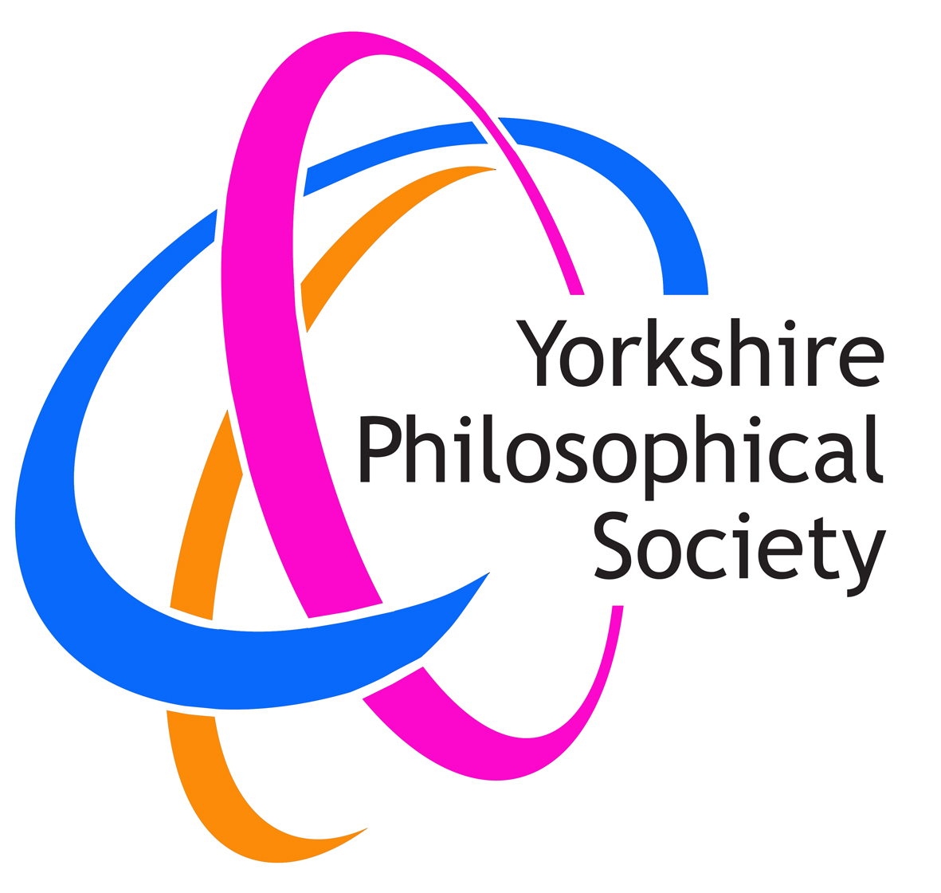

Exploring science and civilisation

Archaeology
Conservation
Engineering
Geology
Health
History
Science
Social Sciences
Technology
Wildlife

Yorkshire Philosophical Society
The Lodge, Museum Gardens
York, YO1 7DR

Tel: 01904 656713
Email: info@ypsyork.org
Website: www.ypsyork.org
Charity Registration No: 529709

2026

